Assignment Activity 17.2: Using NiFi to Load Data to MySQL

1. A screenshot of your MySQL Workbench to show that you have successfully initialized an empty earthquakes table in the usgs database.

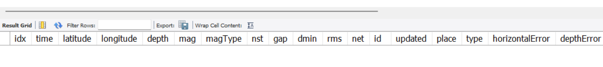

1. A screenshot to show that the Activity17-2.csv CSV file is now on the NiFi server.

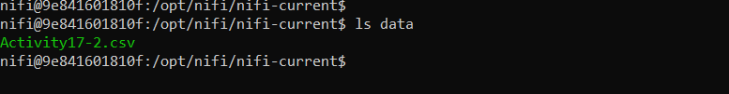

1. A screenshot of the controller screen to show that the three controller services (reader, writer, and MySQL) are enabled.

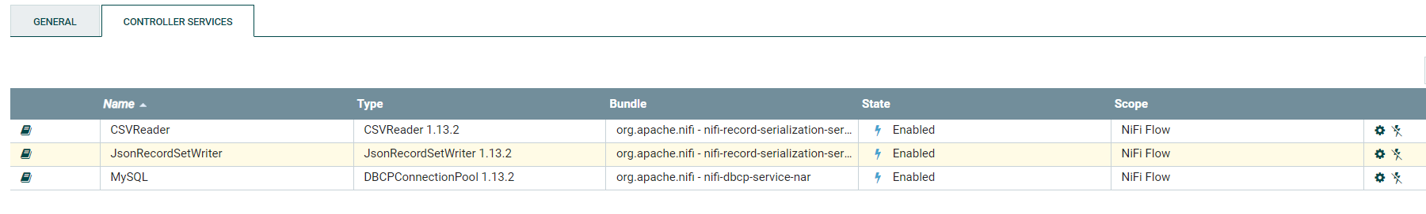

1. A screenshot of your complete data pipeline, including all five processors: GetFile, SplitText, ConvertRecord, ConvertJSONToSQL, and PutSQL.

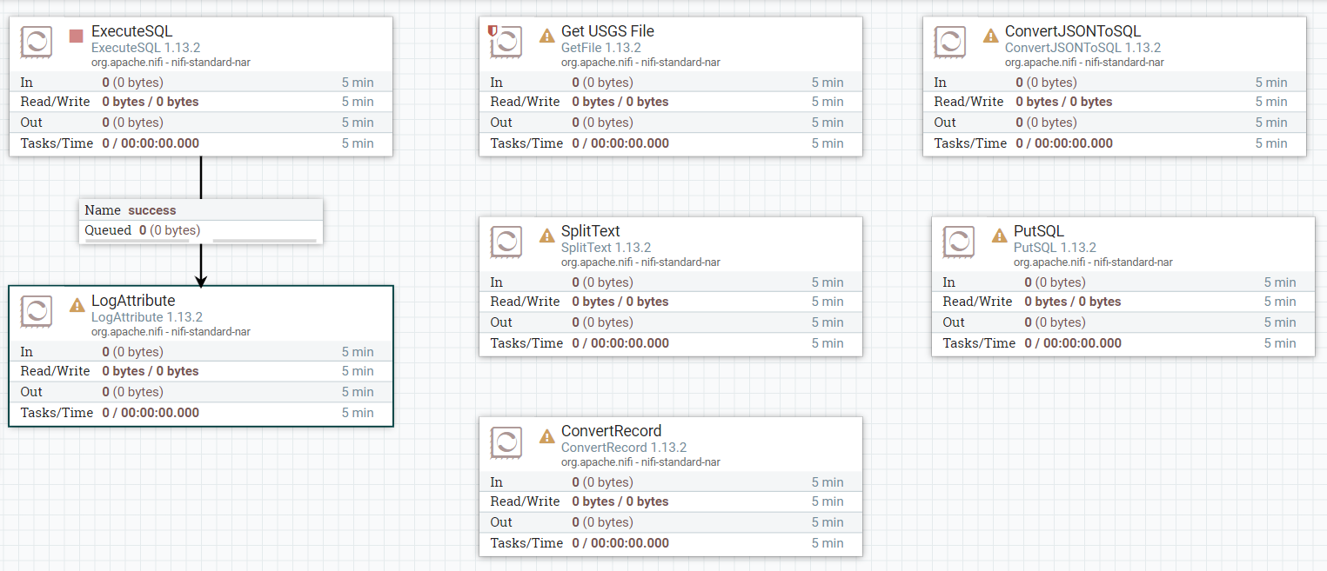

1. A screenshot of all five processors to show that the correct connections have been made.

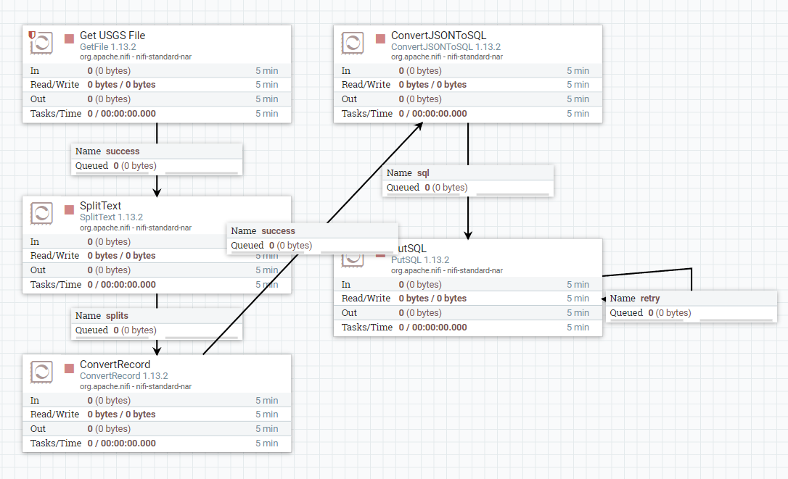

1. A screenshot of your NiFi browser screen to show all five processors connected and running.

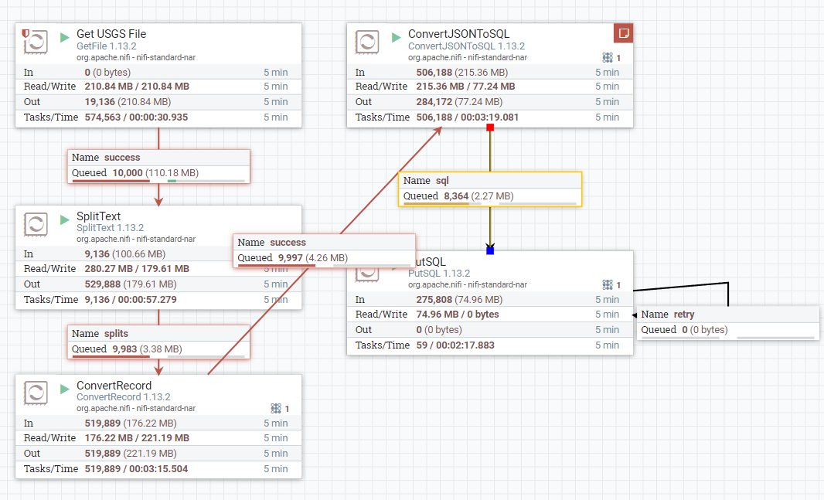

1. A screenshot of the result of this query to show that the earthquakes table in the usgs database is now saturated with data.

